Buckinghamshire BSCP/ Missing & Exploitation Hub
Child Exploitation Screening Tool

Guidance
This Screening Tool is to be used for children and adults up to the age of 24 where there are concerns around exploitation. Exploitation is a form of Abuse, and no-one can consent to their own exploitation. Exploitation can take many forms and can involve criminal, sexual, forced labour and domestic servitude. It is rare that a child or young person only experiences one form of exploitation.
This Screening Tool aims to help professionals focus on the specific indicators of exploitation. Practitioners need to exercise their own professional judgment when completing the tool to analyse the risk of exploitation. It is important to specify what is evidence-based and what is based on “gut feeling”. Professionals should reflect on all contexts where the child spends their time (family, education, peer group, neighbourhood, online).
Once completed, where exploitation is suspected as being current or imminent, the worker should follow local safeguarding procedures. This means that if a child is already open to Children’s Social Care, the allocated Social Worker is notified, and the screening is submitted to the Missing & Exploitation Hub. Where the child is not already open to Children’s Social Care, the professional must complete a Multi-Agency Referral Form (MARF) citing exploitation concerns.
Remember, safeguarding is everyone’s responsibility. Therefore, if you suspect anyone is in immediate danger, call the Police on 999.
When completing this tool, professionals are asked to consider:
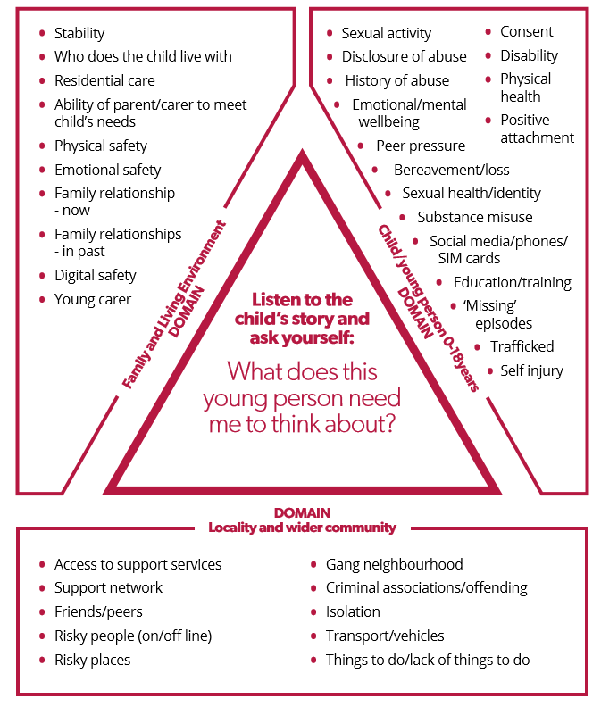

Child/Young Person Details
Name:
Date of birth:
Age:
Current Address/Placement:
Ethnicity:
Diversity (neuro-diverse, speech and language, gender, sexuality, learning difficulties)
Education/Training/Employment/NEET
(name the provision):
Looked After? | Yes  No 
Care Leaver? | Yes  No 

Referrer Details
Your name
Job title and agency
Contact details (email/mobile)
Date completed:

Information Sharing and Disclosure
Is child/young person aware that this tool has been completed? | Yes  No 
Are Parents/Carers aware that this tool has been completed? | Yes  No 
Who else has contributed to the completion of this indicator tool? (child, parent/carer, school, professional)

Has the child made a disclosure of exploitation (abuse)?
Yes  No  If ‘Yes’ you must refer to Children’s Social Care immediately
Names of groomer/exploiter if known (include all known information):

Names of the child’s friends/sibling/others who you think might be affected by exploitation:

- About you (the child/young person) |  |  | Timeframe/date
Significant change in behaviour that out of character (e.g. withdrawn, secretive, fluctuating mood, outbursts, hypervigilance) | Choose an item. | Choose an item.
Physical injuries (e.g. bruising, lacerations) suggestive of physical or sexual assault | Choose an item. | Choose an item.
Sexually Transmitted Infections (STI) or Urinary Tract Infections (UTI) | Choose an item. | Choose an item.
Change in relationships with family members/significant others | Choose an item. | Choose an item.
Pregnancy and/or seeking a termination/emergency contraception | Choose an item. | Choose an item.
Accessing sexual health support outside of what would be expected for their age | Choose an item. | Choose an item.
Change in their appearance, hygiene, self-care | Choose an item. | Choose an item.
Change in eating/sleeping patterns | Choose an item. | Choose an item.
Showing signs of emotional distress (self-harm, suicidal ideation) | Choose an item. | Choose an item.
Use of substances that exceed finances | Choose an item. | Choose an item.
Been found in possession of substances beyond what would be considered as personal use | Choose an item. | Choose an item.
Possession of unexplained items (e.g. clothing, substances, money/cards, weapons, packages) | Choose an item. | Choose an item.
Detachment from age-appropriate activities/significant interests | Choose an item. | Choose an item.
Please provide evidence for every YES response

2. About where you live |  |  | Timeframe/date
Experiencing parental difficulties e.g. parental substance misuse, offending, physical/mental health, domestic abuse | Choose an item. | Choose an item.
Suffered recent bereavement/loss/separation | Choose an item. | Choose an item.
Experiencing unstable accommodation (consider length of placement, care providers, living out of area) | Choose an item. | Choose an item.
Conflict in the home | Choose an item. | Choose an item.
Concerns of physical/sexual/emotional abuse or neglect at home | Choose an item. | Choose an item.
Financial difficulties in the home | Choose an item. | Choose an item.
Concerns around supervision in home (consider emotional/physical availability of parents/carers) | Choose an item. | Choose an item.
Spending increasing amount of time away from home | Choose an item. | Choose an item.
Please provide evidence for every YES response

- About your friendships |  |  | Timeframe/date
Changes in relationship between peers | Choose an item. | Choose an item.
New relationships with peers which raise professional concern | Choose an item. | Choose an item.
Association with a peer already open to the Missing & Exploitation Hub | Choose an item. | Choose an item.
Concerning sexual contact/relationship e.g. age, imbalance of power, coercion | Choose an item. | Choose an item.
New contacts with people outside of town | Choose an item. | Choose an item.
Abduction or false imprisonment | Choose an item. | Choose an item.
Spending significant periods of time away from home with unknown peers | Choose an item. | Choose an item.
Disclosure of serious violence/offending/antisocial behaviour with peers | Choose an item. | Choose an item.
Please provide evidence for every YES response

About your education |  |  | Timeframe/date
Concerning pattern of attendance (late, absence) | Choose an item. | Choose an item.
Missing education (suspensions, exclusions, not registered) | Choose an item. | Choose an item.
Education provision not meeting the needs of the child | Choose an item. | Choose an item.
Significant change in behaviour/achievement in school | Choose an item. | Choose an item.
Accessing a reduced education timetable | Choose an item. | Choose an item.
Please provide evidence for every YES response

About where you spend your time |  |  | Timeframe
Disclosure of feeling unsafe outside of the home | Choose an item. | Choose an item.
Behaviour suggestive of anxiety in the community e.g. hypervigilance, paranoia, checking self | Choose an item. | Choose an item.
Seen entering or leaving unknown vehicles | Choose an item. | Choose an item.
Spending time/visiting a location that professionals are concerned about (clearly state the address) | Choose an item. | Choose an item.
Significant change in normal daily routine | Choose an item. | Choose an item.
Reported missing | Choose an item. | Choose an item.
Concerns around unreported missing | Choose an item. | Choose an item.
Travel out of area / increased travel | Choose an item. | Choose an item.
Located at a property associated with exploitation (trap house, brothel, factory, hotel) | Choose an item. | Choose an item.
Frequent use of taxis | Choose an item. | Choose an item.
Please provide evidence for every YES response

About your digital life |  |  | Timeframe/date
Unusual use of mobile phones or internet (multiple phones, leaving as soon as text/call, unknown numbers, receiving call/text at unusual hours) | Choose an item. | Choose an item.
Change in internet/phone use (secretive, excessive, limited) | Choose an item. | Choose an item.
Mobile phone being answered by unknown person | Choose an item. | Choose an item.
Accessing Apps/websites that are not age-appropriate (list them) | Choose an item. | Choose an item.
Online ‘relationship’, or an online friendship which has developed into an offline ‘relationship’ | Choose an item. | Choose an item.
Sending/receiving sexual images of self or others online | Choose an item. | Choose an item.
Threats received through digital media | Choose an item. | Choose an item.
Unexplained transactions on bank account | Choose an item. | Choose an item.
Unexplained credit/rewards received on Apps/gaming accounts | Choose an item. | Choose an item.
Socially isolated and seeking relationships online | Choose an item. | Choose an item.
Please provide evidence for every YES response

Overall vulnerabilities:
(Consider factors that may make a child/young person overall more vulnerable to exploitation e.g. self-esteem, emotional wellbeing, gender, sexuality, learning disability, young carer).

Positives/strengths:
(Identity what strengths exist for the child/young person. Consider in the contexts of family, peers, education, neighbourhood, online)

What next
- If the child/adult is open to Children’s Social Care: send screening tool to exploitationreferralsmailbox@buckinghamshire.gov.uk
- If the child/adult is not open to Children’s Social Care: completed MARF citing exploitation concerns

Further information around child exploitation can be found at: https://familyinfo.buckinghamshire.gov.uk/advice-and-support/family-safety/child-exploitation/

